Infant Son Andrews
September 17, 1906 – October 21, 1906

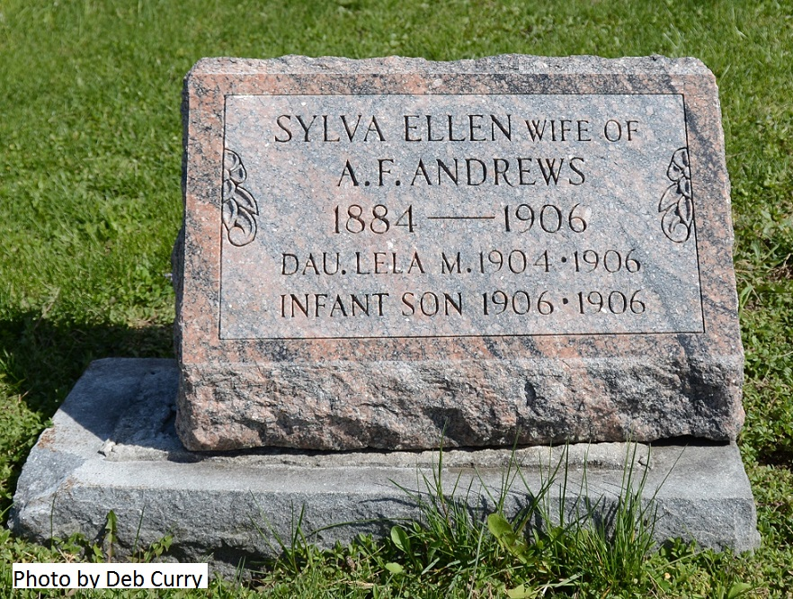

The little child of Adrian Andrews, of Decatur, died at the home of Robert Andrews in Blue Creek township Sunday morning. Mr. Andrews has lost his entire family, his wife and two children in less than a week. The last death was caused from diphtheria and the supposition is that the whole family died of the same disease.

Berne Witness, Adams County, Indiana; Tuesday, Oct. 23, 1906
*****

Indiana, Death Certificates, 1899-2011
Name: Infant Andrews
Gender: Male; Race: White; Age: 1/12; Marital Status: Single
Birth Date: 17 Sep 1906; Birth Place: Adams Co
Death Date: 21 Oct 1906; diphtheria; Death Place: Monroe, Adams, Indiana, USA
Father: Arden Andrews; Mother: Sylva Ray
Burial: Oct. 21, 1906; Salem Cem.

Both contributed by Karin King

