Gerald N. Bixler
September 19, 1918 – April 16, 1975

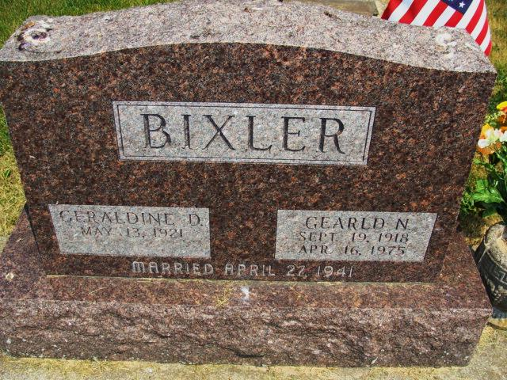
Photo by Alicia Kneuss

Gerald N. Bixler, 56, of 221 South 10th St., auctioneer for the Montpelier (O.) Auto Auction for 23 years, died unexpectedly at 1:15 a.m. this morning at his home. Death was attributed to a heart attack.
He was a member of the First United Methodist Church, Elks Lodge, FOP Lodge, and American Legion post 43 of Decatur. Mr. Bixler was a licensed auctioneer in both Indiana and Ohio, and a graduate of the Reppert auction school.
The well-known auctioneer was a veteran of World War 11 serving in the European Theatre.
Born in Blue Creek township on September 19,1918, he was a son of Eli and Grace Rickner-Bixler, and was united in marriage on April 27, 1941 to Geraldine Ray.
Survivors include the wife; two children, Mrs. Robert (Donna) Shraluka of Decatur; Gregory Bixler of route 2, Defiance, O.; four sisters, Miss Leota Bixler of route 6, Decatur; Mrs. Alton (Mildred) Corson of route 2, Syracuse; Mrs. Floyd (Martha) Yost of Belmont, Calif.; Mrs. Ralph (Faye) Harvery of Sidney, O.; two brothers, Leo Bixler of Fort Wayne; Raymond Bixler of route 1, Decatur; and four grandchildren.
Funeral services will be held at 10:30 a.m. Friday at the Zwick funeral home, with Rev. Wilson Bixler officiating. Burial will be in the Tricker cemetery. Friends may call at the funeral home after 12 noon on Thursday.

Decatur Daily Democrat, Adams County, IN Wednesday, April 16, 1975

Contributed by Janice Vasilovski

