Gordon William “Bill” Burkhart
May 22, 1928 – December 9, 2005

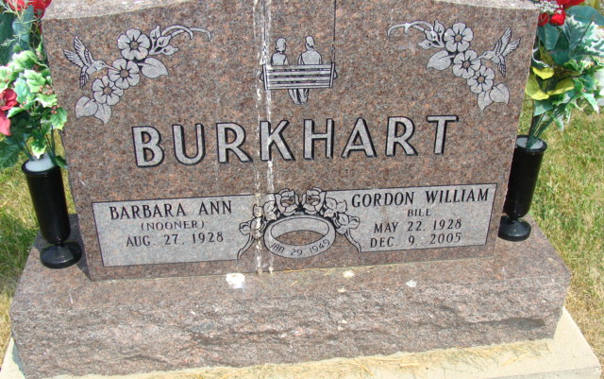
Photo by Alicia Kneuss
Gordon "Bill" Burkhart, 77 years old of Decatur, Indiana, passed away on Friday, December 9, 2005 in Woodcrest Nursing Center where he had been a patient the past week. He was born on, May 22, 1928 in Monroe, Indiana the son of the late Carl David Burkhart and the late Dolly May (Richards) Burkhart. He married Barbara Ann Nooner on January 29, 1949 in Monmouth, Indiana.
Bill retired in 1990 from Kelly's Dry Cleaners with 42 years of service.
Surviving are his wife, Barbara Ann Burkhart of Decatur, Indiana, daughter & companion, Darlene Garner & Jay Kirchner of Decatur, Indiana, son & daughter-in-law, Randy & Susie Burkhart of Duluth, Georgia, daughter & companion, Elana Garcia & Al Binning of Willshire, Ohio, daughter, Tammy Burkhart of Decatur, Indiana, daughter & son-in-law, Billie Jo & Greg Rumschlag of Decatur, Indiana, sister, Betty Halberstadt of Richmond, Indiana, nine grandchildren, and four great-grandchildren.
Preceding Bill in death were three brothers, Wilber Lester, Robert Clifford and Richard Edward Burkhart.
Funeral services will be held at 2:00 p.m. Monday, December 12, 2005 in the Zwick & Jahn Funeral Home with Pastor Mo Hodge officiating. Interment will follow in the Tricker Cemetery, Monroe, Indiana.
Friends will be received from 11:00 a.m. to 3:00 p.m. and 4:00 p.m. to 6:00 p.m., Sunday, December 11 at the Zwick & Jahn Funeral Home, Decatur, Indiana.
Preferred memorials are to Adams County Community Foundation Cancer Fund or the Family Hospice of Northeast Indiana.

Zwick & Jahn Funeral Home online obit (accessed December 10, 2005)

