Rev. Joseph E. Gibson
December 1, 1900 – July 14, 1993

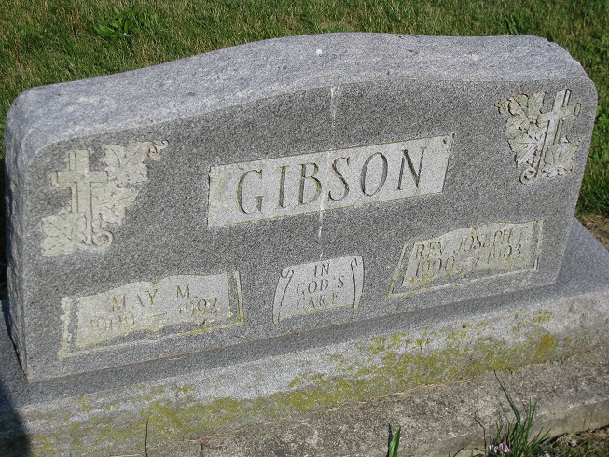
Photos by PLS

Rev. Joseph E. Gibson, 93, of Berne died Wednesday in Parkview Memorial Hospital. He retired in 1967 from the North Indiana Conference of the United Methodist Church after 55 years. After retirement, he served Mount Pleasant United Methodist, Friends, Monroe and Emanuel Churches. His wife, May, died last year.
Surviving are daughters, Theresa Shaw of Berne, Evangeline Gibson of Atoka, Okla., and Donna Carter of Hartselle, Ala.; sisters, Dorothy Gormley of Stockton, Calif., and Cora Hall and Marjorie Lay, both of Santa Barbara, Calif.; three grandchildren; and nine great-grandchildren. Services are 3 p.m. Sunday in Trinity United Methodist Church, Berne, where calling is 2 to 5 and 7 to 9 p.m. tomorrow and 2 to 3 p.m. Sunday. Burial will be in Tricker Cemetery. Arrangements are by Haggard & Armes Funeral Home, Decatur. Preferred memorials are gifts to the church.

Fort Wayne News-Sentinel (IN); Friday, July 16, 1993

Contributed by Jane Edson

