Bessie M. (Shaffer) Hamrick
July 28, 1889 – November 6, 1968

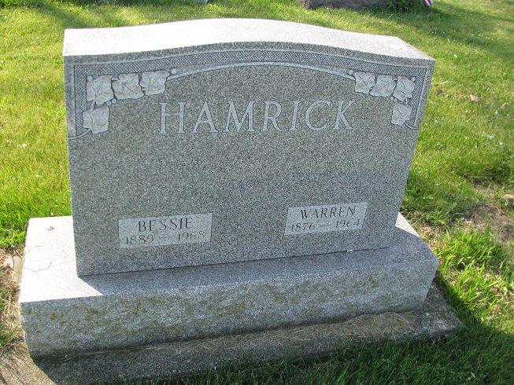
Photos by PLS

Services for Mrs. Bessie M. Hamrick, 79, of 615 E. State Blvd., will be at 10 am Saturday in D.O. McComb & Sons Funeral Home, the Rev. Ray Tucker officiating. Burial will be in Tricker Cemetery, Adams County.
Mrs. Hamrick died at 6:15 am yesterday in Parkview Memorial Hospital where she had been a patient one month. She had been a Fort Wayne resident most of her life. She was a member of Lake Avenue Church of the Nazarene.
Surviving are a brother, Minor Schaffer, Indianapolis; two stepsons and several nieces, nephews and grandchildren.
Friends may call at the funeral home after 7 pm today.
Fort Wayne Journal-Gazette (IN); November 7, 1968

*****
Indiana, Death Certificates, 1899-2011
Name: Bessie M Hamrick [Bessie M Shaffer]
Gender: Female; Race: Wh; Age: 79; Marital Status: Widowed
Birth Date: 28 Jul 1889; Birth Place: Indiana
Death Date: 6 Nov 1968; Death Place: Fort Wayne, Allen, Indiana, USA
Father: Reason Shaffer; Mother: Louisa Robinson
Informant: Gladys Billington, niece
Burial: Nov. 9, 1968; Tricker

Contributed by Karin King

