Harlen Harvey Jones
January 1, 1887 – January 6, 1972

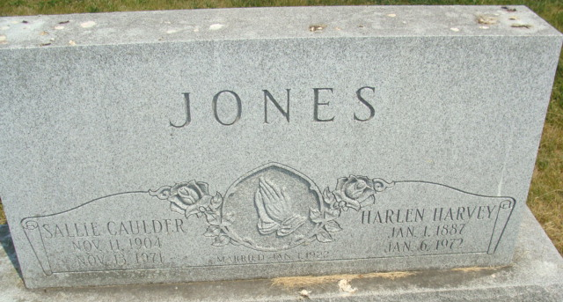
Photo by Alicia Kneuss

Harlen H. Jones Dies at Hospital

Harlen H. Jones, 85, of Decatur Route 6, a retired farmer, died at 3:05 a.m. today at the Lutheran Hospital in Fort Wayne, where he had been a patient since Nov. 6. He was born in Van Wert, County, O., Jan. 1, 1887, a son of Benjamin and Mary Dailey-Jones, and was married to Sallie O. Caulder Jan. 1, 1922. His wife preceded him in death Nov. 13, 1971. Mr. Jones was a member of the Pleasant Mills United Methodist church.
Surviving are four sons, Harvey L. Jones of Decatur Route 6, Benjamin Jones of Sweetser, Glen L. Jones of Berne, and Karl Jones of San Jose, Calif.; three daughters, Mrs. Jack (Mary Ann) Bebout of Decatur Route 6, Mrs. George (Doris) Ray of Marion, and Mrs. James (Martha) Von Gunten of Berne; one sister, Mrs. Charley (Anna) Voltz of Ohio City, O.; one brother, Clyde Jones of Ohio City; 17 grandchildren and five greatgrandchildren.
Funeral services will be conducted at 1:30 p.m. Sunday at the Zwick Funeral Home, with Rev. William McClintock and Rev. Joseph Gibson officiating. Burial will be in the Tricker Cemetery. Friends may call at the funeral home after 7 p.m. Friday until time of the services.

Berne Library Heritage Room
More Misc Obits, dated January 6, 1972
Transcribed by Janice Vasilovski
*****

HARLEN H. JONES

DECATUR – Harlen H. Jones, 85, of Rt. 6, Decatur, a retired farmer, died at 3:05 a.m. Thursday in Lutheran Hospital in Fort Wayne, where he had been a patient since Nov. 6. A native of Van Wert County, he was born east of Wren, Jan. 1, 1887, a son of Benjamin and Mary (Dailey) Jones. He was married Jan. 1, 1922, to Sallie O. Caulder, who preceded him in death November 13, 1971. Mr. Jones was a member of the Pleasant Mills United Methodist Church.
Surviving are four sons, Harvey L. of Rt. 6, Decatur, Benjamin of Sweetser, Ind., Glen L. of Berne and Karl of San Jose, Calif.; three daughters, Mrs. Jack (Mary Ann) Bebout, of Rt. 6, Decatur; Mrs. George (Doris) Ray of Marion and Mrs. James (Martha) Von Gunten of Berne.

Van Wert Times Bulletin (OH); January 7, 1972

