Ernest C. Lautzenheiser
August 24, 1910 – December 25, 1992

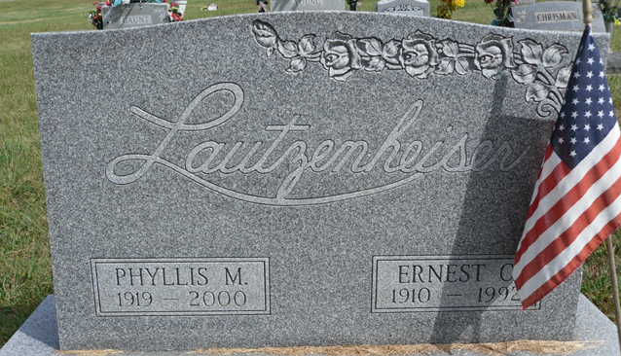
Photo by Tombstoner & Family and PLS

Ernest Lautzenheiser, 82, RR 2, Geneva, died Friday morning at Chalet Village Nursing Home, Berne. He was retired from Berne Furniture Co., and was a member of the First United Methodist Church, Geneva. A veteran of World War II, he was a founder and life member of the Geneva VFW and life member of American Legion Post 43, Decatur. Born Aug. 24, 1910, in Adams County, he was the son of Frank and Bessie (Smitley) Lautzenheiser. He was married Jan. 10, 1948, to Phyllis Jackson, who survives.
Surviving besides his wife are two sons, Bernard Lautzenheiser, Geneva, and Roger Lautzenheiser, Portland; one sister, Mrs. Delbert (Fern) Augsburger, Decatur; four grandchildren and two great grandchildren. Services are set for 2 pm Tuesday in the Haggard and Armes Funeral Home, Decatur, with the Rev. Ron Bishop officiating. Burial will be in Tricker Cemetery at Monroe. American Legion Post 43 will conduct military graveside services.
Memorials may be made to the Arthritis Foundation.

Commercial Review, Portland, IN; December 28, 1992

Contributed by Jim Cox

