George Clinton Lautzenheiser
December 10, 1885 – September 30, 1949

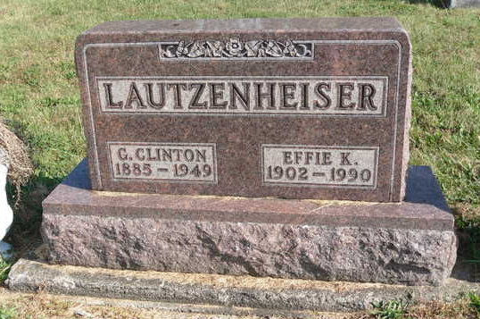
Photo by Grace Derrah

George Clinton Lautzenheiser, 63, custodian of Hoaglin-Jackson School, died at 5:30 am today at Van Wert County Hospital following an emergency operation. He became ill Wednesday when he was taken to the hospital.
Born December 10, 1885, in Adams County, Ind., he resided in Willshire before moving to Hoaglin Township four years ago. He served four years as school custodian and prior to that time was an employee of the County Highway Department for six years.
Surviving are his widow, Effie; seven sons, Gerald, Phillip, Ray, Marlin and Kenneth, all at home; George of near Hoaglin-Jackson School and Dean, stationed with the Army Air Force at San Antonio, Texas; two brothers, Frank of Monroe, Ind., and Roy of Montpelier, Ind.; two sisters, Mrs. John Tinkham of Willshire and Mrs. Emma Teagarden of Winchester, Ind., and a grandson.
Services in charge of the Didrick Funeral Home will be held Sunday at 2 pm at Mt. Pleasant Church. Rev. Elwood Botkins will officiate, assisted by Rev. L. A. Middaugh. Burial will be in Tricker Cemetery near Salem, Ind.

Contributed by mpgenroots - no source listed

