Harold Arden Masters
December 5, 1905 – November 19, 1982

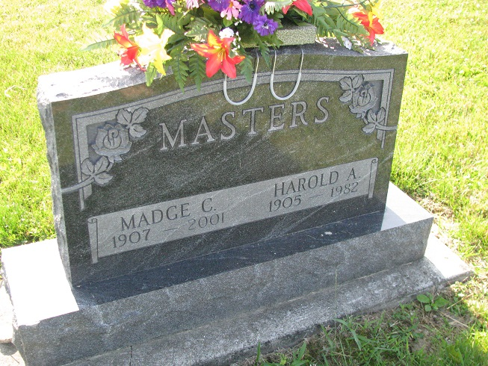
Photos by PLS

Harold A. Masters –

Services at 10:30 am Monday at Zwick-Boltz & Jahn Funeral Home, Decatur, with calling there from 2 to 5 and 7 to 9 pm today.
Memorials to Wells County Hospice.

Fort Wayne Journal-Gazette (IN); November 20, 1982

