Martha Dott (White) Morrison
October 22, 1892 – February 6, 1982

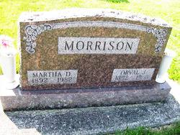
Photos by PLS

Martha Dott Morrison, 69, Route 6, Decatur, Ind., (St. Mary’s Township, south of Pleasant Mills), died Saturday at the Adams County Memorial Hospital, where she had been a patient for one week.
Mrs. Morrison, widow of Orval Morrison, had been a patient at the Berne Nursing Home.
A housewife, she was born October 22, 1892 in Mercer County to William and Martha Ann Davis White, and was married on January 1, 1913; her husband passed away on April 15, 1968.
She was a member of the Willshire Methodist Church.
Surviving are a son, Charles W. Morrison, Route 7, Decatur; two grandchildren, Wilfred Morrison of Rochester, New York and Robert Morrison of Chicago, Ill., along with two step great-grandsons and three great-granddaughters. Five brothers and four sisters are deceased.
Funeral services were held at 10:30 am today (Wednesday) at Zwick-Boltz & Jahn Funeral Home, Decatur. Burial was in the Tricker Cemetery.

Photo Star, Van Wert, Van Wert County, OH; February 10, 1891
(From the Florence Gause Collection)

