Esther Marie Riff
March 22, 1908 – March 23, 1911
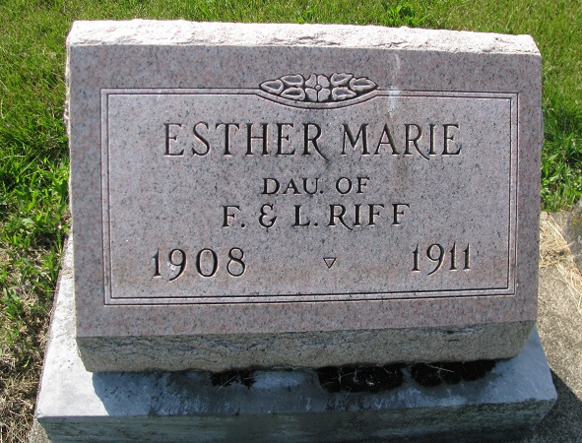
Photo by PLS
The little three-year-old daughter and only child of Mr. and Mrs. Fred Riff living at Muncie, died last week of brain fever and spinal trouble. The family formerly lived about six miles east of town near Salem, and the corpse was brought to Monroe Saturday, the funeral being held at the Salem church Sunday. By some misunderstanding the friends and the hearse met the Saturday morning train at Berne, but the corpse had been billed to Monroe.
Berne Witness, Adams County, Indiana; Tuesday, March 28, 1911
Contributed by Karin King
*****
The funeral of Esther Marie, the three year old daughter of Fred and Lula Riff, of Muncie, was held at Salem Sunday afternoon at 2 o'clock, the Rev. D. A. J. Brown officiating. Interment was made in the Tricker cemetery. The young parents are distracted with grief from the sudden shock, the little one having been in perfect health until only two days before her death.

Berne Witness, Adams County, Indiana; Friday, March 31, 1911
Contributed by Karin King
*****

Obit, Esther Marie RIFF, daughter of Fred and Lula RIFF, was born March 22, 1909 (sic); died March 24, 1911; aged 3 years 2 days. Survivors: father, mother, grandfather, grandmother. Funeral held at Salem March 26th. Interment Tricker cemetery.

The Willshire Herald, Thursday, April 6, 1911, No. 11, Vol. XVI, P7

