Steven Brent Riley
August 9, 1941 – April 17, 2011

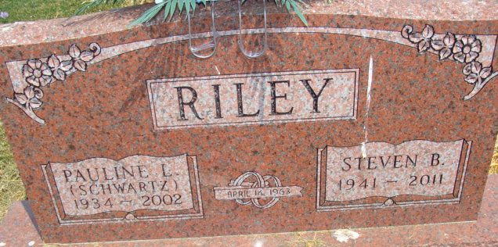
Photo by Alicia Kneuss

Steven B. Riley, 69, a lifelong resident of rural Monroe, died at 7:26 p.m. Sunday in Lutheran Hospital at Fort Wayne, where he had been a patient for six days. He was born to Merle and Ida Girod Riley, who are deceased. He married Pauline Schwartz on April 14, 1963; she passed away in 2002. He was a member of Salem Community Church, serving as chairman of the board of trustees for many years. He was a member of the Adams County Sheriff's Department's reserves from 1963-79 and was involved in the Adams County Citizens' Band Radio Club. He served on the Blue Creek Township Advisory Board and was a precinct committeeman in Blue Creek Township during the 1980s; He graduated from Pleasant Mills High School in 1959 and was employed by the Adams County Highway Department from 1963 to 2003.
Surviving are two brothers, Norman Riley (and wife Elizabeth) of Decatur and Gale Riley (and wife Janelle) of Monroe, plus nephews and nieces.
A funeral service will be held at 3 p.m. Thursday in Zwick and Jahn Funeral Home, Decatur, with Pastor Jim Compton officiating. Burial will be in Tricker Cemetery, rural Adams County. Visiting hours are 1-9 p.m. Wednesday in Zwick and Jahn Funeral Home. Preferred memorials are to Salem Community Church.

Decatur Daily Democrat, Adams County, IN; Tuesday, April 19, 2011
Contributed by Jane Edson

*****
Steven B. Riley, 69 years old of Monroe, Indiana, passed away at 7:26 p.m. on Sunday, April 17, 2011 in the Lutheran Hospital of Indiana located in Fort Wayne, Indiana where he had been a patient for the past 6 days. Steve was born on Saturday, August 9, 1941 in Decatur, Indiana the son of the late Merle Riley and the late Ida (Girod) Riley. He married the late Pauline Schwartz on April 14, 1963 in the Evangelical Mennonite Church in Berne, Indiana and she passed away on June 4, 2002.
Steve was a member of the Salem Community Church where he had served as Chairman of the Board of Trustees for many years. He was on the Adams County Sheriff's Reserves from 1963 to 1979 and was involved in the Adams County C. B. Radio Club. Steve served on the Advisory Board and was prescient Committeeman for Blue Creek Township during the 1980's.
Steve graduated from Pleasant Mills High School in 1959 and was employed by the Adams County Highway Department from 1963 to 2003. He served as a foreman for the highway department from 1990 to 1996.
Surviving are his brother, Norman (Elizabeth) Riley of Decatur, Indiana; brother, Gale (Janelle) Riley of Monroe, Indiana; and several nephews and nieces.
Funeral services will be held at 3:00 p.m. Thursday, April 21, 2011 in the Zwick & Jahn Funeral Home with Pastor Jim Compton officiating. Interment will follow in the Tricker Cemetery, Monroe, Indiana. Friends will be received from 1:00 - 9:00 p.m. Wednesday, April 20, 2011 in the Zwick and Jahn Funeral Home, Decatur, Indiana.
Preferred memorials are to Salem Community Church.

Zwick & Jahn Funeral Homes online obit (accessed 4/18/2011)

