Wesley Evans
February 25, 1844 – February 11, 1911

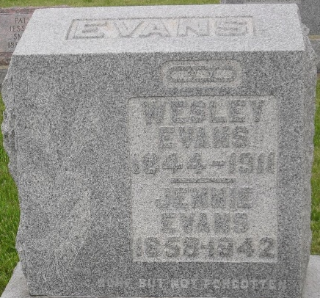
Photo by Jenna Langston

Wesley Evans living about six and a half miles east of Berne was born February 25, 1844, and died Feb. 11, 1911, bringing his age to 66 years, 11 months, and 17 days.
Mr. Evans received a stroke of paralysis in the forepart of last November and has been confined to his bed constantly since about eight weeks ago.
His first marriage was to Miss Millie Eley, sister to Jacob Eley in town. Seven children were born to this union, two sons and two daughters living, and three children having preceded him in death. This union was dissolved when his wife died Jan. 1, 1893, of lung fever. On Dec. 26, 1894, he was again married to Jennie Heller. This union was blessed with three children, two daughters and one son, all of whom are living.
He leaves to mourn the loss of his bereaved wife, four sons, three daughters, one brother, Austin Evans and one sister, Mrs. Millie Blackford. The deceased was a member of the Campbellite church.
Funeral will be held tomorrow forenoon at 10 o'clock and will be in charge of the Odd Fellows and Rebekkah Lodges.

Berne Witness, Adams County, Indiana
February 14, 1911

**
John Evans, who was here attending the funeral of his father, Wesley
Evans, has returned to his home in Michigan.
Berne Witness, Adams County, Indiana
Friday, Feb. 24, 1911

**
COURT PROCEEDINGS

W. V. Buckmaster, administrator in the estate of Wesley Evans, deceased, vs. Jennie Evans, surviving widow, et al., partition. Raleigh C. Parish was appointed guardian ad litem of Ethel F., Eithel P. and Charles L. Evans, minor defaulting defendants. Jennie Evans was found to be the owner on an undivided one-third part of the land in value, and the defendants, John W. Evans, Emma Lotter, Mary Reichard, Bynes A. Evans, Ethel F., Eithel P. and Charles L. Evans, each one, an individual two-twenty-first part thereof in value; also that the defendant Life Insurance company holds a first mortgage lien of $1,025.84. On account of indivisibility the land is ordered sold at private sale at not less than appraisement, in parcels of forty acres, or as a whole, at the best advantage. Terms, one-third cash, one-third in one year, and one-third in two years. John C. Moran appointed commissioner is to pay first. Its share of costs, and the costs of the sale, and then to the plaintiff administrator, enough to pay debts of the estate of Wesley Evans, the balance going to the parties as above found, and the full one-third to the widow, Jennie Evans, less its share of costs.

Berne Witness, Adams County, Indiana
Tuesday, October 3, 1911
**
Indiana, U.S., Death Certificates, 1899-2017
Name Wesley Evans
Gender Male
Race White
Age 66
Marital Status Married
Birth Date 25 Feb 1844
Birth Place Ohio
Death Date 11 Feb 1911
Death Place Jefferson, Adams, Indiana, USA
Death Registration Date 1911
Father: Louis Evans
Mother: Lilly Pence
Spouse: Jennie
Informant: Mrs. Jennie Evans
Burial: February 15, 1911; Mt. Hope Cemetery

