Francis Edward Luginbill
April 7, 1940 – June 18, 2001

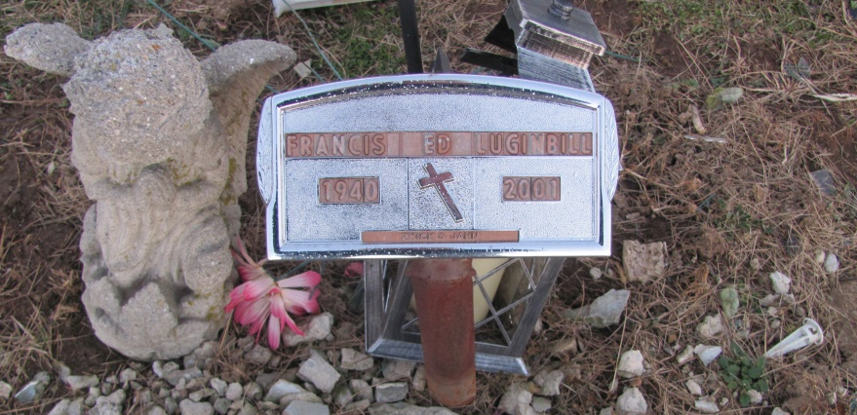
Photo by Time Out Of Mind

Francis Edward "Ed" Luginbill Jr., 61, of rural Monroe, self-employed in the skid loader/hauling business, died Monday, June 18, 2001, at Adams County Memorial Hospital.
The Adams County native retired in 1995 from B.F. Goodrich after 34 years of service. He was a member of Mount Hope Church of the Nazarene in Berne, Loyal Order of Moose 1311 in Decatur and Willard Cemetery Board.
Surviving are his wife, Donna; daughters Leesa Huston of Monroe, Lori Smith and Tina Fourman, both of Decatur; a sister, Ann Stout of Decatur; brothers Richard and Phil, both of Decatur, and David of Monroe; eight grandchildren; and one great-grandchild.
Services are 11 a.m. Thursday at Mount Hope Church of the Nazarene, Berne, with calling one hour before services. Calling is also from 1 to 4 and 5 to 8 p.m. Wednesday with an 8 p.m. Moose service at Zwick & Jahn Funeral Home, Decatur. Burial will be at Mount Hope Willard Cemetery. Memorials are to Fort Wayne Oncology or the church.
Information provided by Zwick & Jahn Funeral Home, Decatur.

News-Sentinel, The (Fort Wayne, IN) - Tuesday, June 19, 2001

Contributed by Jane Edson

*****
Indiana, Death Certificates, 1899-2011
Name: Francis Edward Luginbill Jr
Gender: Male; Race: White; Age: 61; Marital Status: Married
Birth Date: 7 Apr 1940; Birth Place: Jefferson Twp Indiana
Death Date: 18 Jun 2001; Death Place: Decatur, Adams, Indiana, USA
Father: Francis Luginbill; Mother: Pauline Derickson; Spouse: Donna L Dedolph
Informant: Donna Luginbill; wife; Monroe, Ind.
Burial: June 21, 2001; Mt. Hope Cem., Berne, Ind.

