Carol L. (Foreman) McCollum
July 6, 1942 – December 21, 1977

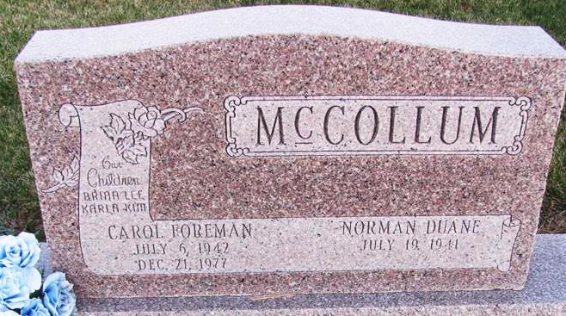
Photo by Jenna Langston

Carol L. McCollum, 35, wife of Norman D. McCollum, Route 1, Geneva, died unexpectedly in her home in Geneva this morning. She had been in failing health for some time but was up and around and had taken her son to work this morning. A little later her daughter found her on the floor in their home.
Mrs. McCollum was a native of Berne and was born July 6, 1942, the daughter of True and Pearl Luginbill Foreman. She married Norman McCollum April 8, 1961, at the High Street Church in Geneva. She was a Geneva High School graduate.
Surviving are the husband; a daughter, Kim, 11 and a son, Brian, 16, both at home; the father, True Foreman who lives on Route 2, Geneva; a sister, Mrs. Larry (Vera) Ellenberger, Bryant and a brother, Gerald D. Foreman, Route 1, Berne.
The body is at the Downing Funeral Home in Geneva where friends may call from 2 to 5 and 7 to 9 pm Thursday. Services will be held at the funeral home at 1:30 pm Friday, Rev. Robert James officiating. Burial will be in Mt. Hope Cemetery.

Florence Gause Collection
December 21, 1977

