William Howard Parr
August 8, 1915 – December 24, 1943

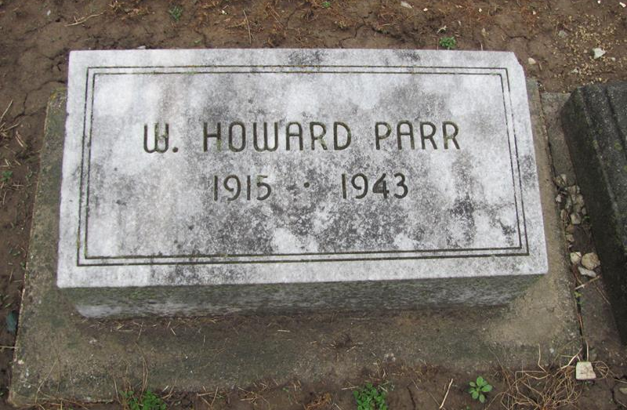
Photo by Jenna Langston

(Handwritten date is cut off, but does look like handwritten is "Joyce Ann also survive")
William Howard Parr, 28, son of Mr. and Mrs. T. M. (Dick) Parr, east of town, was instantly killed in an automobile accident on Christmas evening at 7 o'clock, at Las Vegas, Nevada, according to word received by his parents here early Sunday morning. Particulars of the fatal accident are not known, except that Mr. Parr had been employed as a driver for the Blue Cab company in Las Vegas, and that a cab he was driving and an automobile collided.
The message of the fatal accident was the first information that the family had had of the unfortunate young man for some months. He had been home the last time on Christmas eve a year ago.
In a telephone conversation on Monday evening, between the local mortician, Jerome Yager, and a Las Vegas mortician, an inquest of the body had been held on Monday after which it was planned to ship the body here for burial. The body was to leave Las Vegas Tuesday evening and will probably not arrive here before Thursday night or Friday.
The deceased was born in Blue Creek township on August 8, 1915, on the farm where the parents are residing along road 118, east of Berne. He had resided in this community most of his life.
The news of the tragedy is a severe blow to his family, especially his mother who is convalescing from a severe operation recently, having been critically ill for many weeks.
Surviving are the parents and ten brothers and sisters: Marcus, Dorothy, wife of Jess Brewster, Ruth, wife of Vilas Luginbill, and Bert, all of the community east of town; Helen, wife of Noble Reynolds of Decatur, Martha, wife of Daniel Price of Bluffton, Jim, east of town and Orel, Mary and Sam at home.

Adams County (IN) Historical Society
1943b Scrapbook, Image 166
Transcribed by Karin King
*****

Friday, December 31, 1943

Rites for Howard Parr To Be Held Monday P.M.
Remains Arrive from Nevada This PM; Draft Status Cleared by Board

The body of William Howard Parr, 28, who was fatally injured in an auto accident at 7 o’clock on Christmas evening at Las Vegas, Nevada, arrived at Ft. Wayne this afternoon and was brought to the Yager Mortuary here and will be taken to the home of the parents, Mr. and Mrs. T. M. Parr east of Berne this evening. Accompanying the body here was Mrs. Parr.
Funeral services will be held on Monday afternoon at 2 o’clock at the Bethel Brethren Church with Rev. W. F. Johnson conducting the service and Rev. W. H. Schaffer assisting. A short house service will precede the memorial at the church. Burial will be in the Willard Cemetery more commonly known as Mt. Hope Cemetery.
Mr. Parr, whose whereabouts had not been known by members of his family here for some months, prior to his fatal accident, particulars of which have not been learned and Mrs. Parr could not be interviewed at press time.
In justice to the unfortunate members on the Adams County Selective Service Board today requested that a statement be made regarding Mr. Parr’s status with that board to set the public aright on conflicting reports concerning draft delinquency. Mr. Parr, the board stated, was delinquent only in one item, that of not having supplied a forwarding address. The board stated that that is not considered a serious violation and that there are many others in a similar status. Mr. Parr had not been called for induction and was therefore not delinquent in the sense that he had avoided induction. He had not been called to report and was listed delinquent only with reference to address.
There have also been continuing rumors regarding the circumstances of the tragedy, none of which bear credence. The local morticians are the only persons here who have any information to report of the tragedy and all that was learned is that it was an accident.

Adams County Historical Museum
1943A Scrapbook, image 16

