Jake J. B. Schwartz
March 25, 1911 – February 10, 1972

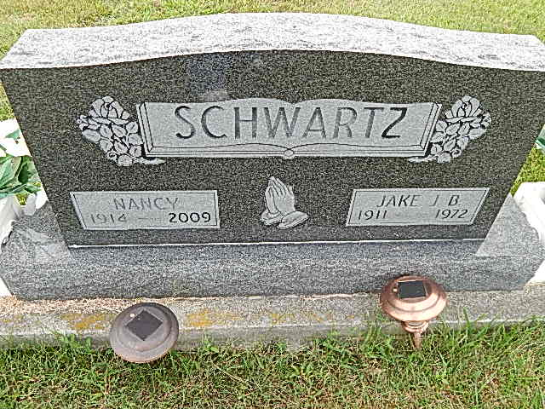
Photo by Alicia Kneuss

Illness of Two Weeks Fatal to Jake Schwartz
Funeral Sunday for Hartford Twp. Man, 60

Jake J. B. Schwartz, 60, R.R. 1, Berne, and widely known in this area, died at 4:30 pm Thursday at the Adams County Memorial Hospital where he had been a patient two weeks following a heart attack. His condition had been critical much of the time since. Mr. Schwartz resided with his family a mile south and 2 ½ miles west of Berne, in Hartford Township.
He had been in failing health for one year. He was employed as a construction worker most of his life.
Mr. Schwartz was born in Blue Creek Township March 25, 1911, a son of John P. and Barbara Schwartz Schwartz. He was married to Nancy Hostettler June 24, 1936.
Surviving are the wife; eight sons, Jake J. Eli J. John J. Daniel D., Samuel J. and Robert J., all of Middlebury, Indiana; William J., Leo, and Melvin J., Ft. Wayne; five daughters, Mrs. Gary (Betty) Miller, Middlebury; Mrs. Joe (Lydia) Wickey, R.R. 2, Geneva; Mrs. Donald (Nancy) Brewster, R. R. 1, Geneva and Barbara and Mary Lou, at home; 22 grandchildren; 10 brothers, Peter M. and Abe B. Schwartz, Nottowa, Michigan; Chris B., Simon B. and Melvin B., all of Colon, Michigan; John B., Redding, Michigan; Sol B., Bluffton; Sam B., Cromwell, Indiana; Amos B., Geneva and Joe B., Berne and a foster son, Jacob Pailey, Farmland, Indiana.
Five sisters survive, Mrs. George (Elizabeth) Blount, R.R. Sturgis, Michigan; Mrs. John A. (Barbara) Schwartz, R. R. 1, Berne, Mrs. Mahlon (Rosa) (cut off)

Berne (IN) Public Library Heritage Room MRE Obits 1968-1970
Transcribed by Jim Cox
*****

Indiana, Death Certificates, 1899-2011

Name: Jake J B Schwartz
Gender: Male
Race: White
Age: 60
Marital status: Married
Birth Date: 25 Mar 1911
Birth Place: Indiana
Death Date: 10 Feb 1972
Death Place: Decatur, Adams, Indiana, USA
Father: John P Schwartz
Mother: Barbara Schwartz
Spouse: Nancy Hostetler, informant
Burial: Feb. 13, 1972; Evangelical Mennonite

