Nancy (Hostetler) Schwartz
March 8, 1914 – June 27, 2009

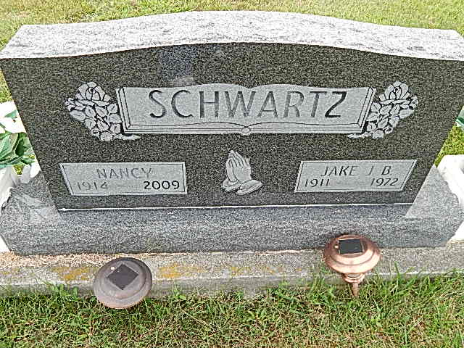
Photo by Alicia Kneuss
Nancy Schwartz, 95, a resident of Adams County, Indiana passed away at 11:35 a.m. Saturday, June 27, 2009 at the Adams Memorial Hospital in Decatur, Indiana.
Nancy was born on March 8, 1914 in Middlefield, Ohio the daughter of Eli and Lydia (Detweiler) Hostetler, both deceased. She married Jacob J.B. Schwartz on June 24, 1935 and he preceded her in death on February 10, 1972.
Nancy was a member of the Evangelical Mennonite Church in Berne, Indiana.
Nancy is survived by a son, Jake (Leah) Schwartz of Middlebury, Indiana; a son, Daniel (Fay) Schwartz of Middlebury, Indiana; a son, John (Doris) Schwartz of Middlebury, Indiana; a son, Melvin (Ruby) Schwartz of Yoder, Indiana; a son, William (Judy) Schwartz of Leo, Indiana; a son, Sam (Dianne) Schwartz of Summerfield, Florida; a son, Robert (Theresa) Schwartz of Seymour, Indiana; a son, Eli (Marylin) Schwartz or Bradenton, Florida; a daughter, Lydia (Wickey) of Berne, Indiana; a daughter, Barbara (Michael) Isch of Berne, Indiana; a daughter Mary (Dean) Reinhard of Berne, Indiana; a daughter, Betty (Gary) Miller of Middlebury, Indiana; and a daughter, Nancy (Bob) Garlinger of Geneva, Indiana. Other survivors include a sister, Sarah Stutzman of Sugarcreek, Ohio; a brother, Jake Hostetler of Sarasota, Florida; a brother, Noah Hostetler of Sarasota, Florida; thirty-nine grandchildren; sixty-seven great grandchildren; and two great-great grandchildren.
Nancy was preceded in death by brothers, Daniel, Eli, and Elmer Hostetler; sisters, Mary Schlabach and Elizabeth Schwartz; and a daughter-in-law, Ruby Schwartz.
Funeral services will be held at 10:30 a.m. Tuesday, June 30, 2009 at the Evangelical Mennonite Church of rural Berne, Indiana with Michelle Isch officiating. Interment will be in the Evangelical Mennonite Church Cemetery.
Family and friends will be received from 2:00 – 8:00 p.m. Monday, June 29, 2009 at the Yager-Kirchhofer Funeral Home in Berne, Indiana.
Preferred memorials are to Caneer or the Evangelical Mennonite Church.

Yager-Kirchhofer Funeral Home, Adams County, IN
June 28, 2007

