Mary (Zehr) Zimmerman
July 21, 1879 – March 19, 1911

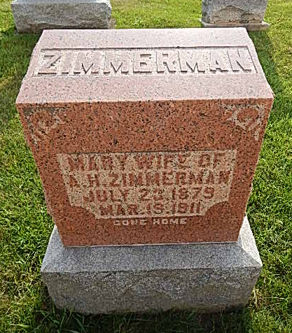
Photo by Alicia Kneuss

Mrs. Amos Zimmerman, living about two miles west of Geneva, died Sunday afternoon about 2 o'clock after a short illness with pneumonia. The funeral will be held tomorrow forenoon at 9 o'clock at the home and at 10 o'clock at the Defenseless Mennonite church west of town.

Berne Witness, Adams County, Indiana
March 21, 1911
Contributed by Karin King
*****
Indiana, Death Certificates, 1899-2011

Name: Mary Zimmeramn [Mary Zehr]
Gender: Female; Race: White; Age: 31y, 7m, 26d
Marital status: Married
Birth Date: 21 Jul 1879; Birth Place: Ind
Death Date: 19 Mar 1911; Death Place: Hartford, Adams, Indiana, USA
Father: George Zehr; Mother: Lydia Roth
Informant: Amos Zimmerman
Burial: 3/22/1911, Defenseless Mennonite

