Barbara (Winkler) Alberson
December 15, 1862 – November 3, 1939

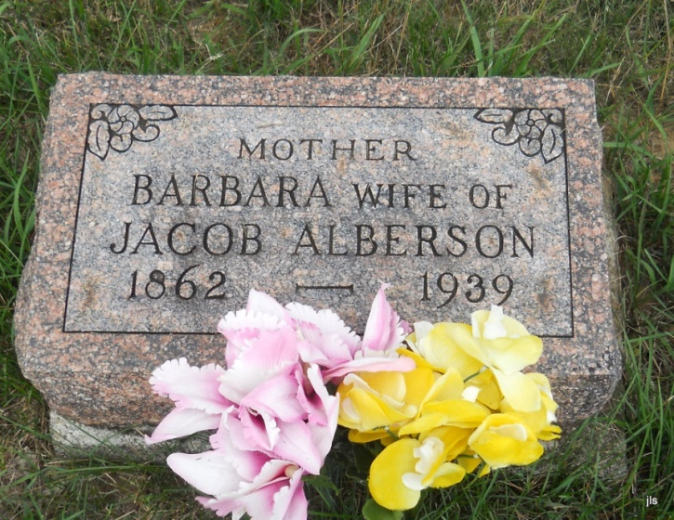
Photo by Jackie Sanders
Former Resident Nottingham Dies
Mrs. Jacob Alberson Dies at Geneva – Funeral Monday at Phoenix

Mrs. Jacob [Barbara] Alberson, 86, a resident of Geneva for 30 years, died Friday at her home. Death was caused by complications.
The decedent was born in Fletcher, O., Dec. 15, 1872, the daughter of Samuel and Sarah Jane Winkler. She was a member of the Methodist church.
Surviving are the husband and the following children: Grover Alberson of Geneva, Mrs. Etta Rinehart of Geneva, Mrs. Edna Alberson, at home; and three granddaughters, Pearl, Dorothy and Bertha Ray.
Funeral services will be held at the home at 1:30 p.m. Monday at 2 o’clock at the Phoenix Church, Rev. Anderson officiating. Burial will be in Alberson Cemetery.
Evening News Banner, Wells County, IN; November 4, 1939, p. 3, c. 3

