Henry Alberson
April 7, 1837 – March 25, 1917

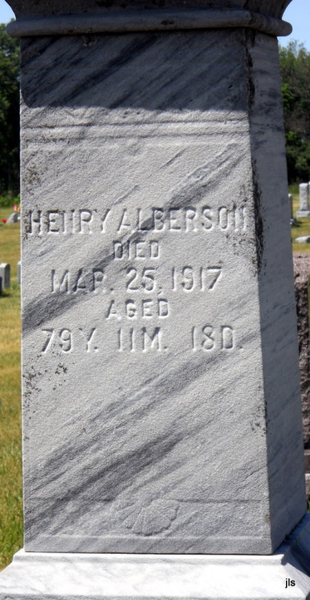
Photo by Jackie Sanders

No obit found at this time

