John Alberson
December 16, 1828 – March 18, 1909
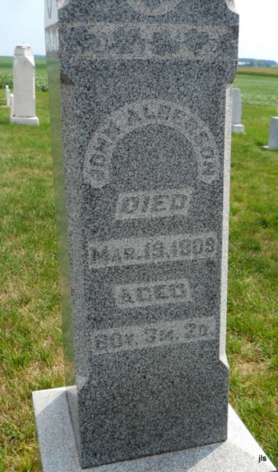
Photo by Jackie Sanders

John Alberson
in the Indiana, Death Certificates, 1899-2011
Name: John Alberson
Gender: Male
Race: White
Age: 80
Marital Status: Widowed
Birth Date: 16 Dec 1828
Birth Place: Indiana
Death Date: 18 Mar 1909
Death Place: Nottingham, Wells, Indiana, USA
Father: John Alberson
Mother: Catharine Deter
Informant: E. A. Gray; Pennville
Burial: Alberson Cemetery

