Joshua Alberson
1794 – January 18, 1879
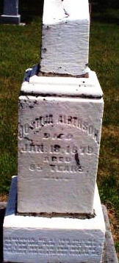
Photo by Jackie Sanders

It is believed Joshua was born in South Carolina and married Catherine Deter on January 21, 1825, Wayne Co., Indiana. In 1829 Joshua purchased land in Randolph Co., Indiana on the north edge of Deerfield and bought more land during 1833 - 1837.
Parents of seven known children: Charles, John, Samuel, Joshua Jr., Henry, Nancy and an Infant child that died. By April, 1851, they had moved to Hartford Township, Adams Co., Indiana and acquired several acres of land near Domestic, a virgin forest at that time, which required many hours of hard work clearing the land to make it productive. On February 25, 1863, the land was deeded to Hartford Township, Adams County for a burial ground which was called Alberson Cemetery.

Contributed by Mildred Ludy

