Rachel A. Alberson
June 21, 1817 – July 22, 1909
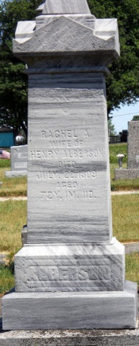
Photo by Jackie Sanders

Mrs. Rachel Alberson, the wife of Henry Alberson, living near Domestic in Wells county, died at eight o'clock on Thursday evening. The deceased was seventy-one years old and her death was caused by the infirmities of old age. The funeral will be held at one o'clock on Sunday at Domestic, and interment will be made in the Alberson cemetery near that place.
Decatur Daily Democrat, Adams County, Indiana; July 23, 1909
Contributed by Karin King

