Virgil Ralph Alberson
September 16, 1907 – July 3, 1968

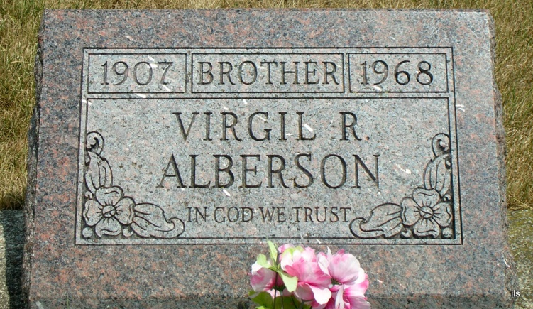
Photo by Jackie Sanders

Virgil Ralph Alberson
in the Indiana, Death Certificates, 1899-2011
Name: Virgil Ralph Alberson
Gender: Male
Race: White
Age: 61
Marital Status: Never Married (Single)
Birth Date: 16 Sep 1907
Birth Place: Indiana
Death Date: 3 Jul 1968
Death Place: Portland, Jay, Indiana, USA
Father: Jacob Alberson
Mother: Barbara Winkler
Informant: Grover Alberson; brother
Burial: July 6, 1968; Alberson Cemetery

