Catherine J. Anderson
1913 – June 22, 1999

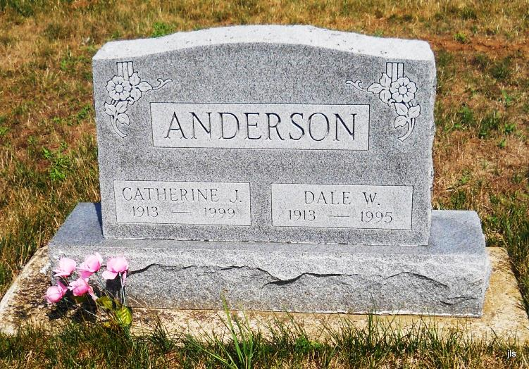
Photo by Jackie Sanders

Catherine J. Anderson, 86, of Jackson, Mich., and formerly of Berne, Ind., died Tuesday, June 22, 1999, in Jackson.
The Grand County, Ind., native was retired from Carson Pirie Scott of Peoria, Ill., in sales and was a member of Trinity United Methodist Church.
Surviving are sons Charles R. of Tucson, Ariz., and Stephen D. of Jackson; a sister, Agnes Landis of Warren, Ind.; four grandchildren; and three great-grandchildren.
She was preceded in death by her husband, Dale W., and a brother.
Services are 1 p.m. Tuesday at Downing Funeral Home, Geneva, Ind., with calling from 11 a.m. until services and also from 6 to 8 p.m. Monday. Burial will be in Alberson Cemetery, Adams County, Ind.
Memorials are to the church or Trinity United Methodist Church of Berne.

News-Sentinel, Fort Wayne, IN; June 25, 1999

