Essie Myrtle (Simmons) Anderson
June 12, 1883 – May 22, 1986

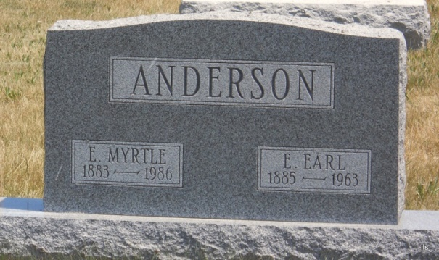
Photo by Jackie Sanders

Essie Myrtle Anderson, 102, died at 10 am Thursday at Wabash Healthcare Center. Her husband, Edwin E., died in 1963.
Surviving are nine grandchildren.
Services at 2 pm Sunday at DeLaughter Mortuary with calling today.

Fort Wayne Journal-Gazette (IN); May 24, 1986, page 5A
*****
Essie Myrtle Anderson
in the Indiana, Death Certificates, 1899-2011
Name: Essie Myrtle Anderson [Essie Myrtle Simmons]
Gender: Female; Race: White; Age: 102
Marital Status: Married
Birth Date: 12 Jun 1883
Birth Place: Indiana
Death Date: 22 May 1986
Death Place: Wabash, Wabash, Indiana, USA
Father: Lon Simmons
Mother: Mary Snyder
Informant: E. E. Clingenpeel; Manchester, Ind.
Burial: May 25, 1986; Alberson Cemetery, Domestic, Ind.

