Henry H. Bailey
September 3, 1905 – March 7, 1983

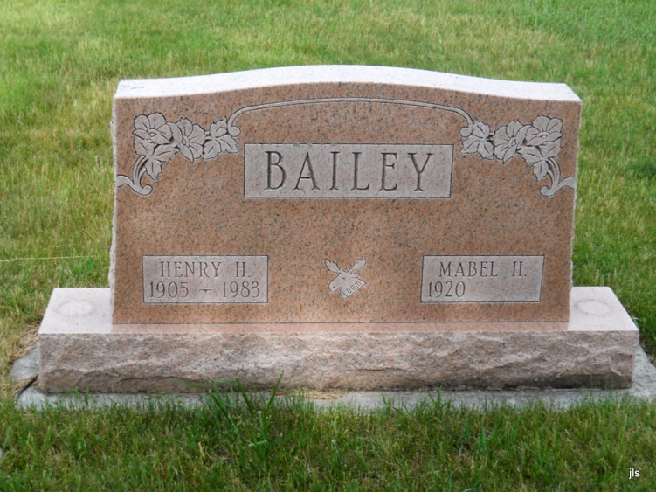
Photo by Jackie Sanders

Henry H. Bailey
in the Indiana, Death Certificates, 1899-2011
Name: Henry H. Bailey
Gender: Male
Race: White
Age: 79
Marital Status: Married
Birth Date: 3 Sep 1903 [sic]
Birth Place: Indiana
Death Date: 7 Mar 1983
Death Place: Bluffton, Wells, Indiana, USA
Father: John Bailey
Mother: Sarah Uptgraft
Spouse: Mabel Riggars
Informant: Mabel Bailey; wife; Bluffton, Ind.
Burial: March 9, 1983; Alberson Cemetery, Petroleum, Ind.

