Oren James Beeler
January 28, 1906 – October 5, 1906

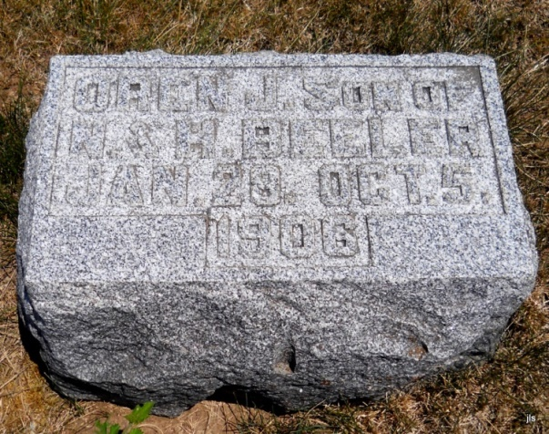
Photo by Jackie Sanders
Oran James Beeler
in the Indiana, Death Certificates, 1899-2011
Name: Oran James Beeler
Gender: Male
Race: White
Age: 8 months, 7 days
Marital Status: Infant
Birth Date: 28 Jan 1906
Birth Place: Indiana
Death Date: 5 Oct 1906
Death Place: Hartford, Adams, Indiana, USA
Father: Noah Beeler
Mother: Hattie Green
Burial: Oct. 7, 1906; Alberson Cemetery

