Emma (Twigg) Bierie
May 2, 1848 – July 22, 1920

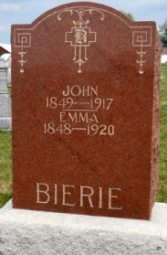
Photo by Jackie Sanders
Emma Bierie
in the Indiana, Death Certificates, 1899-2011
Name: Emma Bierie
[Emma Twigg]
Gender: Female
Race: White
Age: 72
Marital Status: Widowed
Birth Date: 2 May 1848
Birth Place: Indiana
Death Date: 22 Jul 1920
Death Place: Nottingham, Wayne, Indiana, USA
Father: Charley Twigg
Mother: Jane Pusley
Spouse: John Bierie
Informant: Charlie Bierie, Bluffton, Ind.
Burial: July 25, 1920; Alberson Cemetery

