John Bierie
November 12, 1849 – May 13, 1917

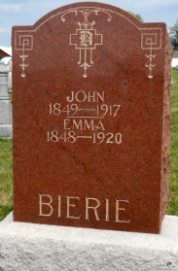
Photo by Jackie Sanders

John Bierie, residing one mile north of Domestic, died Sunday after an illness of only one week.
Besides the wife, three daughters and a son survive.
The funeral service was held at 2 o'clock Tuesday afternoon at Salem, with burial in the Alberson Cemetery.

Fort Wayne News (IN); May 16, 1917

