Bertha A. Blocher
No Dates

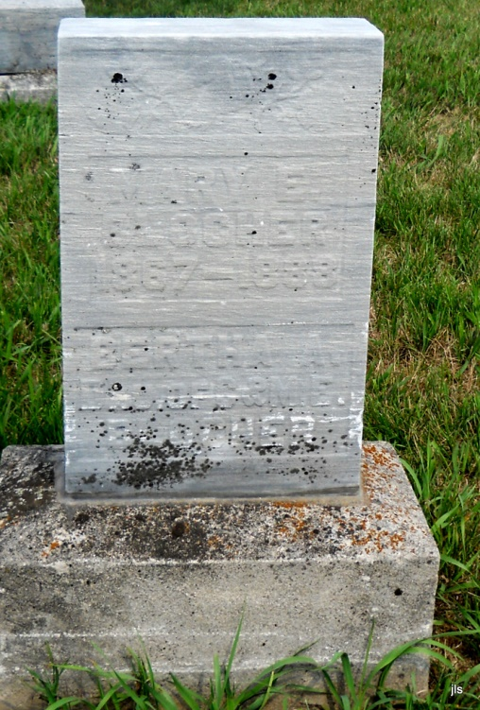
Photo by Jackie Sanders

No obit found at this time

