Rachel Elmyra (Anderson) Borror
December 31, 1894 – February 11, 1960

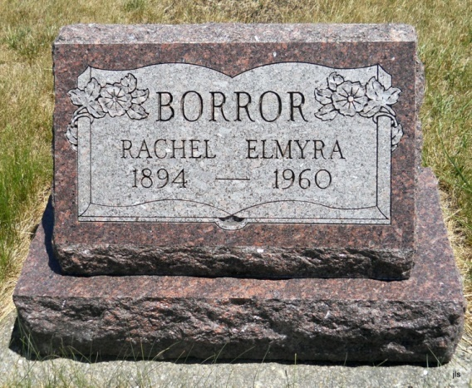
Photo by Jackie Sanders

Adams Public Library System (Decatur, IN) online obit abstracts
Publication: Decatur Daily Democrat; Date: 12 FEB 1960
Title: Borror, Rachel
Subject: Obituaries -- B -- 1960-1969
Abstract: Age 65
Died: Thursday, February 11, 1960 at the Adams County Memorial Hospital
*****
Rachel Elmira Borror
in the Indiana, Death Certificates, 1899-2011
Name: Rachel Elmira Borror
[Rachel Elmira Anderson]
Gender: Female; Race: White; Age: 65; Marital status: Widowed
Birth Date: 31 Dec 1894; Birth Place: Adams Co Indiana
Death Date: 11 Feb 1960; Death Place: Decatur, Adams, Indiana, USA
Father: William Anderson; Mother: Rose Miller
Informant: Miss Betty Anderson; sister; Geneva, Indiana
Burial: Feb. 14, 1960; Alberson Cemetery, near Geneva, Indiana

