George Washington Brookhart
May 8, 1857 – January 25, 1916

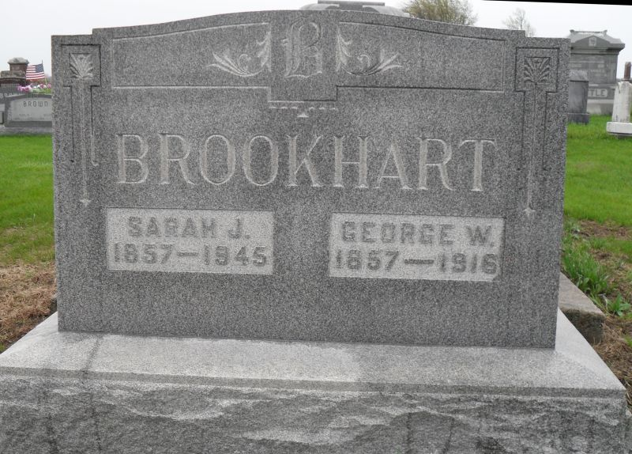
Photo by Jackie Sanders

George Washington Brookhart
in the Indiana, Death Certificates, 1899-2011
Name: George Washington Brookhart
Gender: Male
Race: White
Age: 58
Marital status: Married
Birth Date: 8 May 1857
Birth Place: Ohio
Death Date: 25 Jan 1916
Death Place: Montpelier, Blackford, Indiana, USA
Father: Daniel Brookhart
Mother: Sarah Copp
Spouse: Sarah Jane Brookhart
Informant: Sarah J. Brookhart, Montpelier
Burial: Jan. 28, 1916; Domestic Cemetery

