Lillie (Mitchell) Brookhart-Kirkwood
September 27, 1880 – November 8, 1968

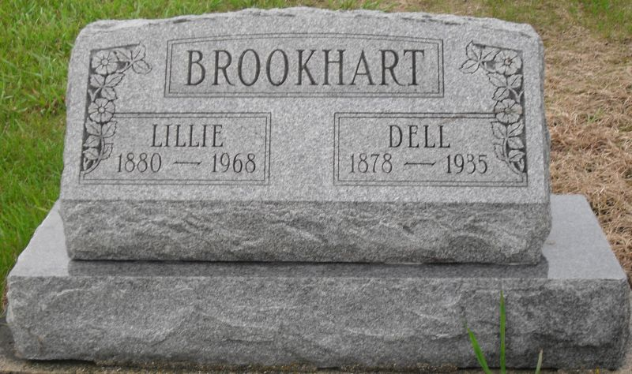
Photo by Jackie Sanders
Lillie M Kirkwood
in the Indiana, Death Certificates, 1899-2011
Name: Lillie M Kirkwood
[Lillie M Mitchell]
Gender: Female
Race: White
Age: 88
Marital status: Widowed
Birth Date: 27 Sep 1880
Birth Place: Indiana
Death Date: 8 Nov 1968
Death Place: Bluffton, Wells, Indiana, USA
Father: David Mitchell
Mother: Mary E Penn
Informant: Dorothy Uptgraft; daughter; Bluffton, Ind.
Burial: Nov. 10, 1968; Alberson Cemetery, Wells County, Ind.

