Cessna Bryan
1858 – July 11, 1936

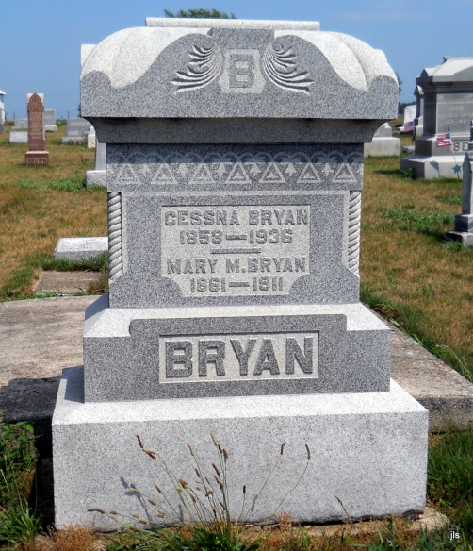
Photo by Jackie Sanders

Bluffton, July 10 –
Cessna Bryan, 79, of Poneto, a retired farmer, died today at the Wells County Hospital here, following an illness of one week of pneumonia and complications. He was a native of Mercer County, O. and had resided in Wells County many years.
He was first married to Mary Muterspaugh who died in 1911.
He is survived by the second wife, who was Luella Watson, and the following children: Otto and Herbert of Fort Wayne, Mrs. Earl Meshberger of Bluffton, Rev. Glen Bryan and Daniel Bryan of Wells County, Mrs. Forrest Shoemaker of Adams County, Mrs. Orval Romey of Fort Wayne, and Burl Bryan of Montpelier. A brother, Franklin Bryan resides at Onsted, Mich.
Funeral services will be held at 2 pm Monday at Union Chapel M. E. Church of which Mr. Bryan was a member, and burial will be in the Alberson Cemetery.

Journal-Gazette, Fort Wayne, IN; July 11, 1936, Page 16

