Herbert T. Bryan
December 4, 1884 – February 17, 1971

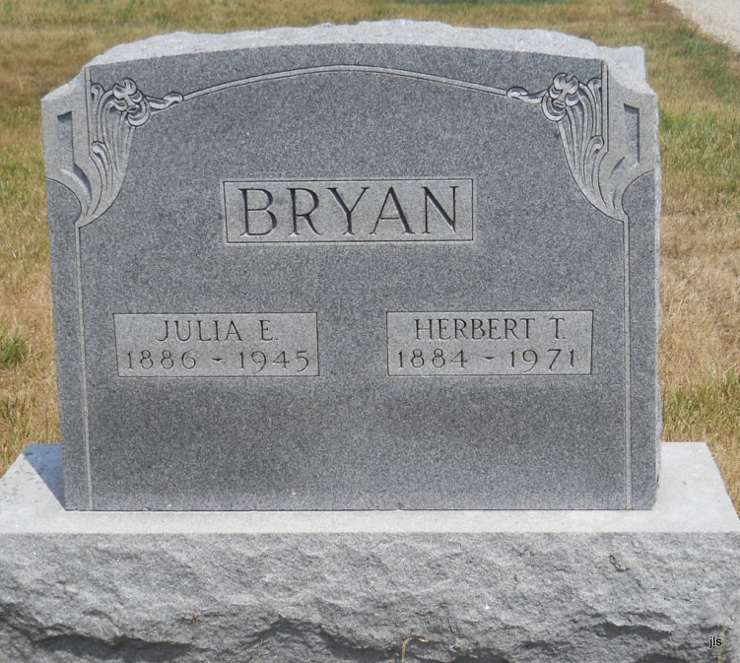
Photo by Jackie Sanders

Herbert T. Bryan, 86, of the Methodist Memorial Home in Warren, died at 7:35 pm Wednesday.
He was a native of Mercer County, Ohio and had formerly lived in Fort Wayne. Mr. Bryan moved to Warren in 1963.
He was a member of Union Chapel at Geneva.
Surviving are two sisters, Mrs. Flossie Shoemaker of Geneva and Naomi Romey of Fort Wayne; and two brothers, Robert B. of Bluffton and Daniel F. of Keystone.
Services will be at 10 am Saturday at the Methodist Home, the Rev. Albert Clarke officiating. Burial will be in Alberson Cemetery near Petroleum.

Fort Wayne Journal-Gazette (IN); February 19, 1971, Page 2A

