Julia E. (Heller) Bryan
June 11, 1886 – March 14, 1945

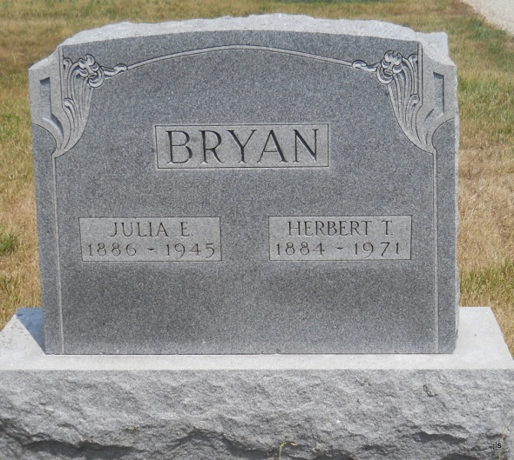

Funeral services for Mrs. Julia Heller Bryan, 58, 1152 ½ Francis Street, who died at 5:45 pm Wednesday at the Medical Center Hospital where she had been a patient for three days, will be conducted at 2 pm Saturday at the Union Chapel Methodist Church, west of Geneva, with the Rev. Charles H. Smith officiating. Interment will be in Alberson Cemetery. The body was removed to the Wells & Hardy Funeral Home, Geneva, and will be taken to the Eckrote Home, 520 Jersey Street, Bluffton, this morning where it will lie in state until the time of services.
Mrs. Bryan lived west of Geneva until she and her husband moved to Fort Wayne several years ago. She was a member of the First Methodist Church.
Survivors include her husband, Herbert; two sisters, Mrs. Emma Bryan, Fort Wayne and Mrs. Francis Eckrote, Bluffton; five brothers, Fred Heller, Muncie, William Heller, Pontiac, Mich., Eugene Heller, Chicago and Milo and Wesley Heller, Minneapolis, Minn.

Fort Wayne Journal-Gazette (IN); March 16, 1945, Page 20

