Leona P. Coffman
November 7, 1900 – April 5, 1930

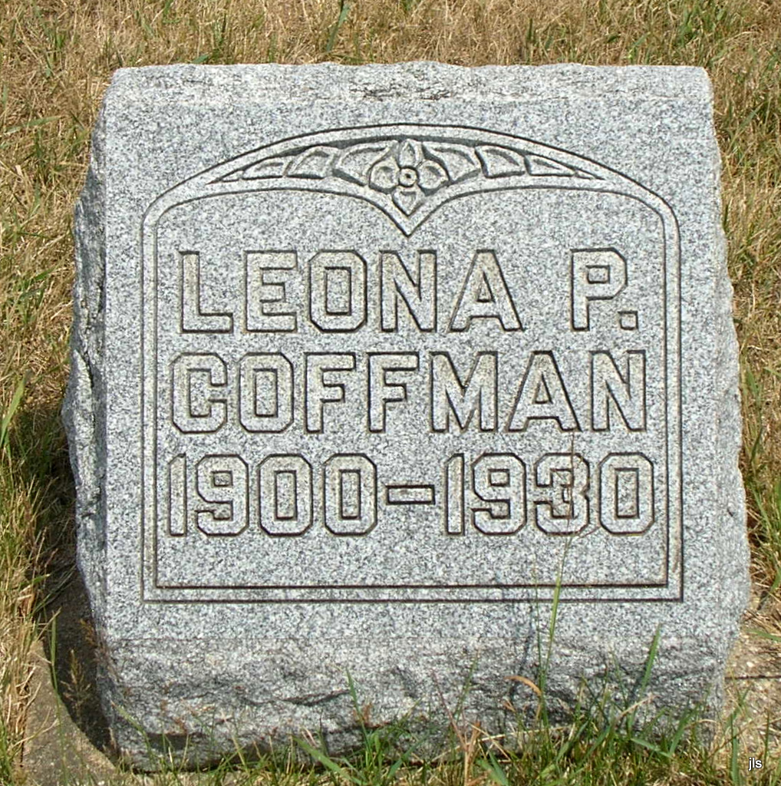
Photo by Jackie Sanders

Leona Coffman
in the Indiana, Death Certificates, 1899-2011
Name: Leona Coffman
Gender: Female
Race: White
Age: 29
Marital status: Single
Birth Date: 7 Nov 1900
Birth Place: Indiana
Death Date: 5 Apr 1930
Death Place: Geneva, Adams, Indiana, USA
Father: Peter Coffman
Mother: Amanda Williams
Informant: Peter Coffman; Geneva, Indiana
Burial: April 7, 1930; Alberson Cemetery

