Charles Arthur Crain
August 27, 1889 – December 25, 1963

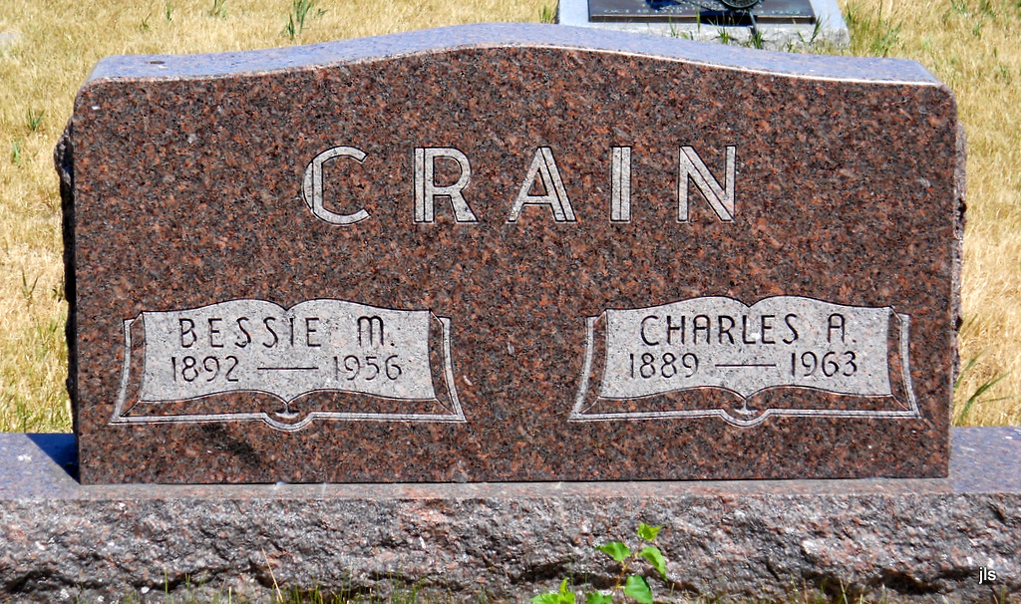
Photo by Jackie Sanders

Charles Arthur Crain
in the Indiana, Death Certificates, 1899-2011
Name: Charles Arthur Crain
Gender: Male
Race: White
Age: 74
Marital status: Married
Birth Date: 27 Aug 1889
Birth Place: Indiana
Death Date: 25 Dec 1963
Death Place: Keystone, Wells, Indiana, USA
Father: Alonzo Crain
Mother: Fannie Koon
Informant: Mrs. Pansy Crain; wife; Keystone, Ind.
Burial: Dec. 28, 1963; Alberson Cemetery, Geneva, Ind.

