Robert L. Edington
May 9, 1914 – August 21, 2003
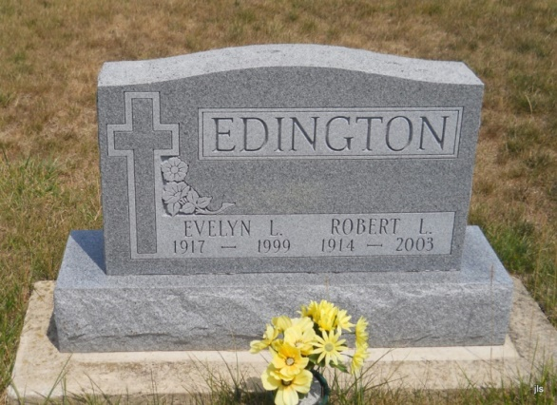
Photo by Jackie Sanders

Robert L. Edington, 89, of Bluffton, died Thursday, Aug. 21 at 2:30 p.m. at Bluffton Regional Medical Center.
Born in Marion on May 9, 1914 to Marion and Cora Dean Edington, he was a life-long resident of Wells County, marrying Evelyn Bryan on Nov. 26, 1936 in Nottingham Township. She died Nov. 25, 1999. He had been a resident at Meadowvale Health and Rehabilitation Center in Bluffton since 1999.
He was a 1939 graduate of Lancaster High School and was a farmer in southern Wells County. He also worked at Dunbar Furniture in Berne for 15 years, retiring in 1980. He was an active member of Grace Baptist Church in Bluffton, serving as head usher for many years.
He is survived by several nieces and nephews. He was preceded in death by a sister, Virgil Kindle; two brothers, Kenneth and Dean Edington; and a foster sister, Mirian Whilhelm.
Calling will be held Saturday from 10 a.m. until the time of the service, which will be held at 11 a.m. Saturday at Thoma/Rich, Hewitt & Chaney Funeral Home, with Rev. Douglas McClure officiating. Burial will be in Alberson Cemetery. Preferred memorials are to the church.

Bluffton News Banner, Wells County, Indiana
August 22, 2003
*****

Bluffton IN, Robert L. Edington, 89, of Bluffton, died Thursday, Aug. 21, 2003. Arrangements by Thoma/Rich, Hewitt & Chaney Funeral Home, Bluffton.

News-Sentinel, The (Fort Wayne, IN) - Saturday, August 23, 2003
*****
Indiana, Death Certificates, 1899-2011
Name: Robert L Edington
Gender: Male
Race: White
Age: 89
Marital status: Widowed
Birth Date: 9 May 1914
Birth Place: Marion, Indiana
Death Date: 21 Aug 2003
Death Place: Bluffton, Wells, Indiana, USA
Father: Marion Edington
Mother: Cora Dean
Informant: Pastor Douglas McClure; Pastor; Bluffton, Ind.
Burial: Aug. 23, 2003; Alberson Cemetery, Petroleum, Ind.

