David Fields
October 8, 1861 – January 17, 1921
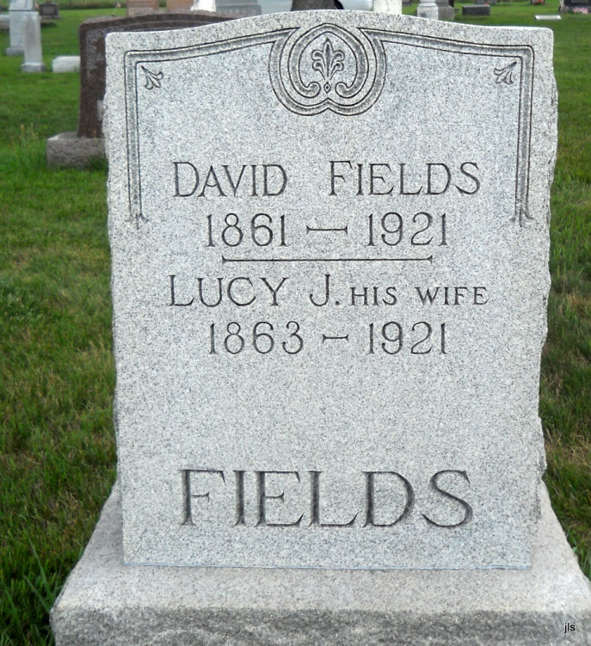
Photo by Jackie Sanders

David Fields, aged 60 years of Geneva, Ind., died in the Hope Methodist Hospital this morning. The body will be taken to Geneva for burial.

News-Sentinel, Fort Wayne, IN; January 18, 1921, Page 20

Contributed by Karin King

