Eva M. (Woessner) Fox
July 26, 1932 – September 3, 2011
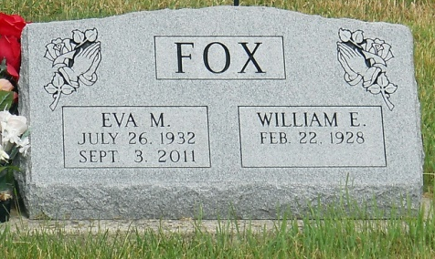
Photo by Jackie Sanders

Eva M. Fox, 79, Bluffton, died at 7:27 a.m. Saturday, Sept. 3, 2011, at Lutheran Hospital in Fort Wayne.
Born in Tiffin, Ohio, on July 26, 1932, to Fred and Marie (Hoffman) Woessner, she married William E. Fox on Oct. 17, 1961, in Bluffton; he survives.
She was a member of Sonlight Wesleyan Church and worked as a waitress at the Dutch Mill and Corner Depot for many years.
Other survivors include two daughters, Linda Bradley and Cindy Stephenson, both of Bluffton; a son, Roger L. Fox of Topeka; two sisters, Bertha Feasel of Tiffin, Ohio, and Thelma Cogar of Fremont, Eva Ohio; 10 grandchildren; 19 great grandchildren; and one great-great-grandchild. She was preceded in death by three brothers, Jack, Robert and Louis Woessner; and two sisters, Ethel McCollum and Alice Smith.
Services will be Thursday at 1:30 p.m. at Goodwin Memorial Chapel with Pastor Lyle Breeding officiating. Calling hours there are Wednesday from 2 to 8 p.m. and Thursday for one hour prior to the service. Burial will be in Alberson Cemetery.
Online condolences may be made at www.thegmcfamily. com.
Bluffton News-Banner, The (IN) — Wednesday, September 7, 2011
Contributed by Jane Edson

