John Edgar Green
August 6, 1870 – June 3, 1923

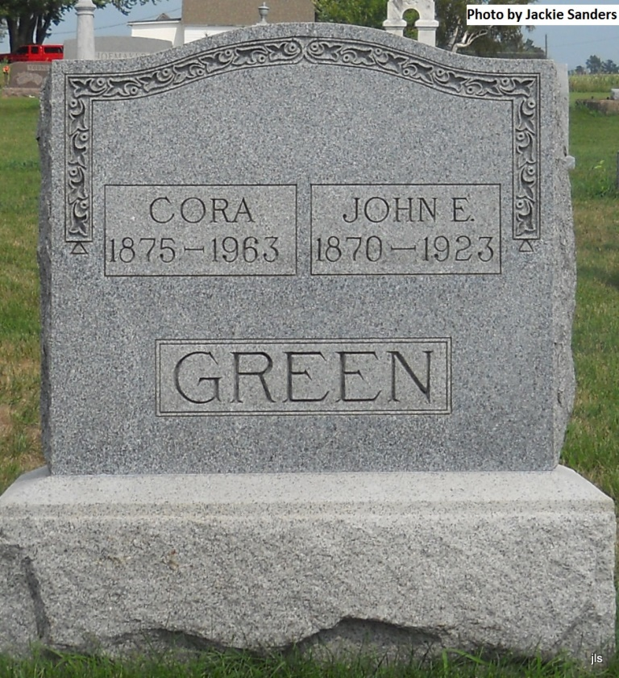
Photo by Jackie Sanders

JOHN E. GREEN DIED AT DOMESTIC SUNDAY

Funeral services were held from the domestic Christian church at 2 o'clock this afternoon for John E. Green, age 51 years, former Adams county man, who died at his home in Domestic Sunday morning. Death was due to tuberculosis, from which he suffered for a number of years. Mr. Green, son of John [sic] and Mary Green, was born in Adams county in 1870. He spent the most of his life in Wells county, however. Surviving Mr. Green are his wife and three children.

Decatur Daily Democrat, Adams County, Indiana; Tuesday, June 5, 1923

Contributed by Karin King

