Philip S. Gross
March 30, 1969 – October 19, 2005
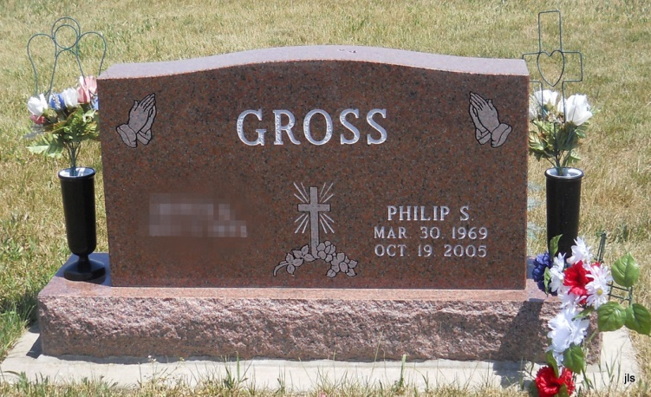
Photo by Jackie Sanders

Philip Gross, 36, 5181 West 200 North, Portland, died Wednesday at Ball Memorial Hospital. Born on March 30, 1969, in Cincinnati, Ohio, to Buloh and Margarett (Clemons) Gross, he married Traci Alberson on July 9, 1993. She survives.
He worked for East Central Opportunities in Muncie and was a member of Union Chapel Church.
Other survivors include his parents Buloh and Margarett, Hartford City; three daughters, Mikayla, Marisa and Mariah Gross; a brother, Nathan Gross, Aurora; and a sister, Jocelyn Tauge, East Enterprise.
Services are Saturday at 10 a.m. in the Baird-Freeman Funeral Home with Jonathan Fightmaster officiating. Burial will be in the Alberson Cemetery.
Visitation will be held on Friday from 4 to 8 p.m. at the funeral home. Memorials may be sent to Union Chapel Church or The Gideon’s International.

Commercial Review, Portland, IN; Friday, October 21, 2005

