Harold J. Guyot
October 31, 1911 – September 14, 2003

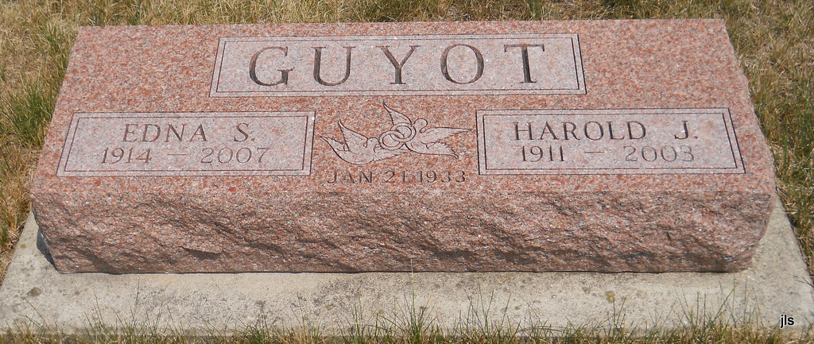
Photo by Jackie Sanders

Harold J. Guyot, 91, Fort Wayne, died Sunday at Hospice Home of Northeast Indiana, Fort Wayne. He was the brother of a Portland resident.
Born Oct. 31, 1911 in Bartlesville, Okla., he was a maintenance worker with General Electric, retiring in 1975 after 34 years of service.
He was a member of Waynedale United Methodist Church and Masonic Lodge 739, Waynedale.
Surviving are his wife, Edna; three sons; a daughter; two sisters, including Emma Grile, Portland; nine grandchildren; 14 great-grandchildren; and two great-great-grandchildren.
Services are Thursday at 11 a.m. at Elzey-Patterson-Rodak Home for Funerals, 6810 Old Trail Road, Fort Wayne. Burial will be at a later date.
Visitation is Wednesday from 2 to 4 p.m. and 6 to 8 p.m. at the funeral home.
Memorials may be made to Waynedale United Methodist Church; Hospice Southwest; or Cancer Services of Allen County.

Commercial Review, The (Portland, IN) - Wednesday, September 17, 2003

