Daniel F. Herman
September 25, 1931 – July 17, 2011

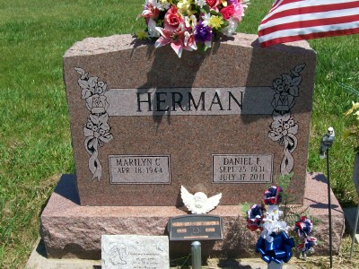
Photo by Scott Shoup

Daniel F. Herman Sr., 79, of Linn Grove, Indiana died at his residence on Sunday, July 17, 2011. He was born on September 25, 1931 in Adams County, Indiana to the late Franklin D. and Jessie (Cave) Herman. On September 19, 1970 he married Marilyn C. Myers.
Daniel retired as a mechanic with Dan's Auto Service and Balsiger Motors. He was a member of the American Legion in Bluffton and V.F.W. in Geneva. He served his country in the Korean War with the United States Army.
He is survived by his wife Marilyn C. Herman of Linn Grove, three sons Daniel F. Herman, David E. Herman and Randy D. Hogg all of Linn Grove; four daughters Rondalyn S. Gagliardo of Watervliet, Michigan, Deb Schott, Diane R. (Chris) Zeitvogel and Pamela K. (Tony) Sigler all of Linn Grove; a brother Bob (Karen) Herman of Geneva; a sister Ruth Watkins of Decatur; 14 grandchildren and 1 great grandchild. He was also preceded in death by 3 brothers, 2 sisters and a granddaughter.
Visitation will be from 2-4 and 6-8 p.m. Wednesday, July 20, 2011 at Haggard-Sefton and Hirschy Funeral Home. Funeral service will be on Thursday, July 21, 2011 at 10:00 a.m. also at the funeral home. Pastor Dave Boots will be officiating and burial will be in Alberson Cemetery with Military graveside rites by American Legion Post #43. Memorials are to Family Hospice and Palliative Care or Adams County Home Health.

