Walter E. Lane
April 4, 1919 – December 19, 1998

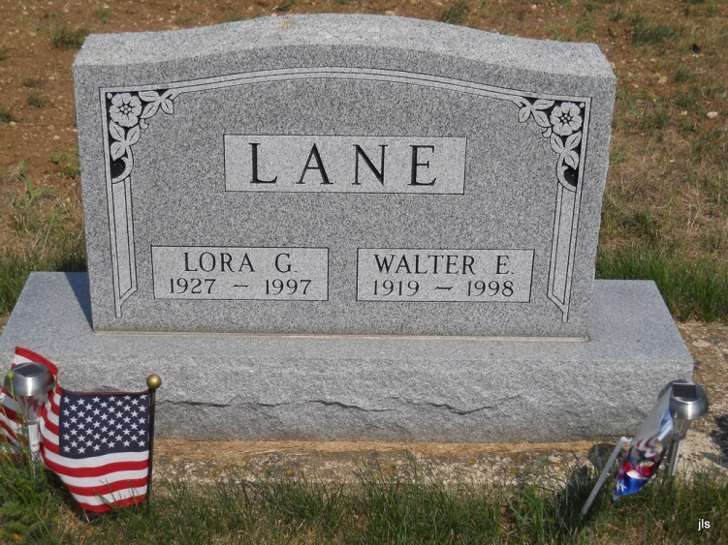
Photo by Jackie Sanders

Walter E. Lane, 79, of Bluffton, a native of Scott County, Va., died Saturday, Dec. 19, 1998, at Caylor-Nickel Medical Center. He worked at Sterling Casting for 18 years.
Surviving are sons Harry and Rodger, both of Bluffton, and Larry of Bartlesville, Okla.; daughters Joan Miller of Bluffton and
Darlene Zerkle of St. Paris, Ohio; sisters, Ana L. Quillen of Bluffton, Monie Gillenwater, Nora Peters and Maxine McConnel, all of Gate City, Fla.; brothers Worley and Lloyd, both of Gate City; 14 grandchildren; and 11 great-grandchildren. He was preceded in death by his wife, Lora, a brother and a sister.
Services are 10:30 a.m. Tuesday at Goodwin Memorial Chapel, with calling from 1 to 8 p.m. today. Burial will be in Alberson Cemetery.

Fort Wayne News-Sentinel (IN); December 21, 1998

