Verle R. (Eckrote) Merriam
April 8, 1902 – September 20, 1945

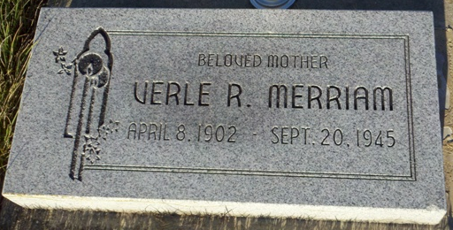
Photo by T & R Melton

Adams Public Library System (Decatur, IN) online obit abstracts
Publication: Decatur Daily Democrat; Date: 21 SEP 1945
Title: Merriam, Verle Eckrote
Subject: Obituaries -- M -- 1940-1949
Abstract: Age 43
Died in New Albany
Married: Hal Merriam
Native of Linn Grove, IN
Parent: Harve Eckrote of Geneva, IN
Notes: ACHS September 21, 1945

Indiana, Death Certificates, 1899-2011
Name: Verle Rachel Merriam [Verle Rachel Eckrote]
Gender: Female; Race: White; Age: 43
Marital Status: Married; Spouse Hallie Merriam
Birth Date: Apr 1902; Birth Place: Lynn Grove, Indiana
Death Date: 20 Sep 1945; Death Place: New Albany, Floyd, Indiana, USA
Father: Harvey Eckrote; Mother: Emma Sales
Informant: Mr. Hallie Merriam of Jeffersonville, IN
Burial: Transit & burial: Sept. 21, 1945; Geneva Cemetery, Geneva, IN

