William Harold Miller
February 6, 1959 – April 2, 2012

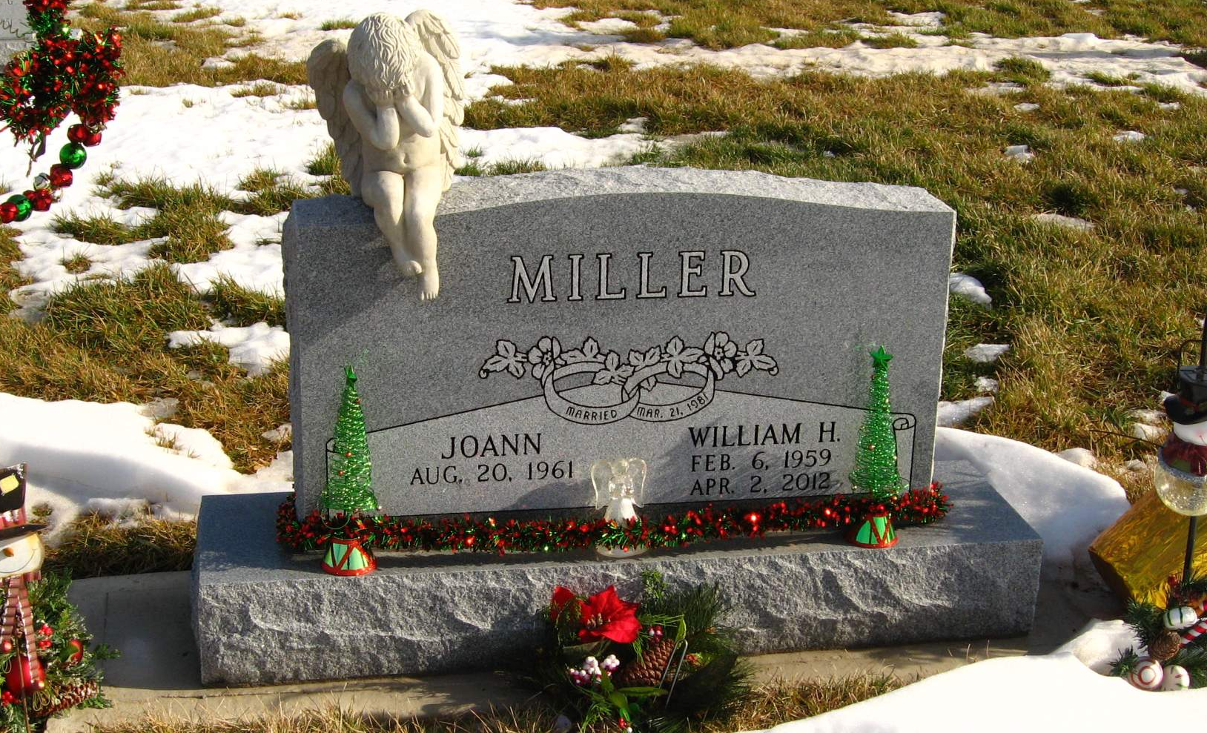
Photo by Tombstoner & Family

William Harold Miller, 53, Geneva, died Monday at Lutheran Hospital. Born in Richmond to William "Bill" R. and Helen D. (Wilson) Miller, he was a graduate of Bluffton High School.
He is survived by his wife Joann (Lane) Miller whom he married on March 21, 1981, in Geneva. He worked for Nesco Truck Sales for many years and attended Trinity Life Chapel in Geneva.
Surviving besides his wife is his father; a son, William R. Miller (wife: Tammy), Geneva; two daughters, Jennifer Brewster, Geneva, and Lora Osborn (husband: Greg), Bluffton; three sisters, Pam Stockey, Fortville, Mary Cowan, Fort Wayne, and Stephanie Shepherd, Franklin; two brothers, Rick Miller, Scottsburg, and Chuck Miller (wife: Annette), Waco, Texas; and three grandchildren.
Services are Saturday at 10:30 a.m. at Goodwin Memorial Chapel in Bluffton, with Pastor Larry Lane and Terry Werst officiating. Visitation is Friday from 2 to 8 p.m. at the funeral home. Memorials may be sent to the family.

Commercial Review, Jay County, IN; April 5, 2012

